|  |  |  |  |
| --- | --- | --- | --- |
| 1 | | 49,262.142857142855 | |
| NUMERO DE FRONTERAS | | ENERGIA AGREGADA | |
|  | | | |
| SI | | 04/09/2020 | |
| CONTRATO | | VENCIMIENTO CONTRATO | |
|  | | | |
| 27,419,681 | 73 | | 1,140,115 |
| INGRESO 2020 | DÍAS CERTIFICADOS 2020 | | ENERGIA RESPALDADA 2020 |
|  | | | |
| 25,475,715 | 37 | | 1,119,406 |
| INGRESO 2021 | DÍAS CERTIFICADOS 2021 | | ENERGIA RESPALDADA 2021 |

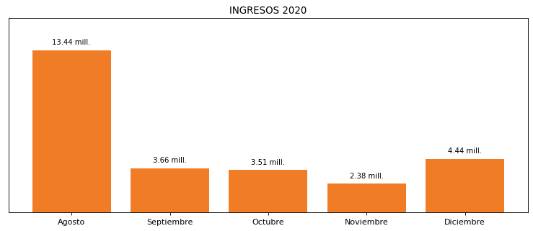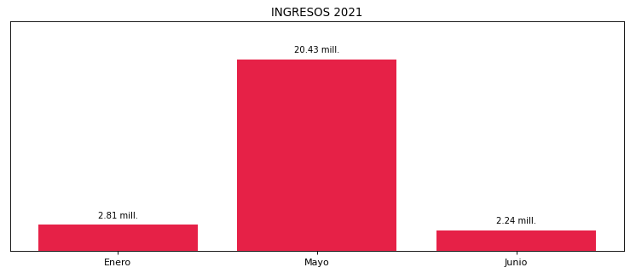

|  |
| --- |
| **FAMILIA RIONEGRO**  USUARIO |

|  |
| --- |
| **Camilo Bermudez**  Ejecutivo de cuenta |

|  |
| --- |
| **Thannia Huertas / Especialista Energía Eléctrica / thanniahc@grupofamilia.com**  Primera fecha: PUNTO FOCAL |

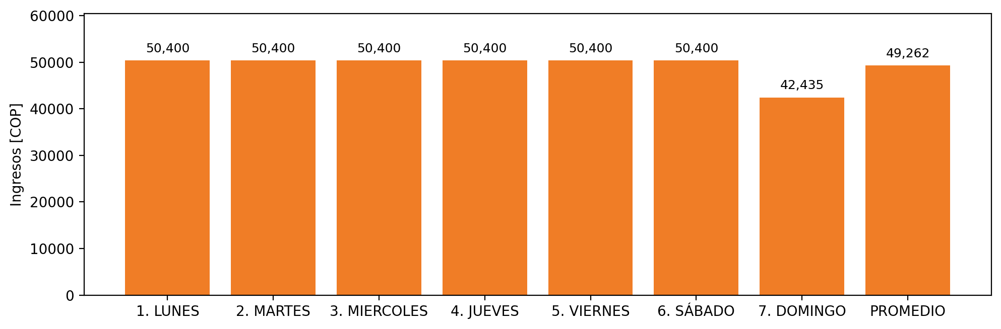

|  |  |  |  |  |  |  |  |  |  |
| --- | --- | --- | --- | --- | --- | --- | --- | --- | --- |
| **FRONTERA COMERCIAL** | **TIPO DDV** | **COD SIC** | **PREDIO** | **PROMEDIO** | **MARGEN** | **ÚLTIMA DESCONEXION** | **DÍAS CERTIFICADOS** | **ACTUALIZACION** | **PROXIMA PRUEBA DDV** |
| PRODUCTOS SANITARIOS SANCELA S.A. | Frt38318 | Frt00607 | Prd02068 | 49,262 | 3,81 | 2021-04-03 | 24.0 | 2022-02-17 | 2022-02-02 |